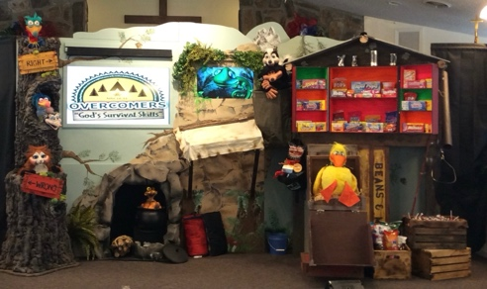
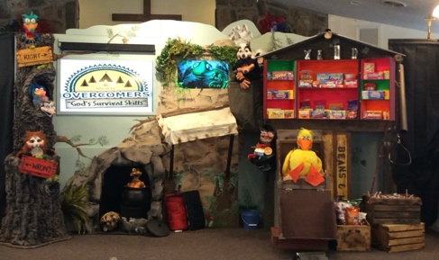
Children’s Crusade
Children’s Crusade
July 17th-20th, 2024 @ 6:30 p.m.
July 18th-27th, 2024 @ 6:30 p.m.
Lighthouse Baptist Church
2581 Northwestern Pike | Winchester, VA 22603
(540) 662-8873 | info@lighthousewinc.com
www.lighthousewinc.com | Luke Shope, Pastor
Lighthouse Baptist Church
2581 Northwestern Pike | Winchester, VA 22603
(540) 662-8873 | info@lighthousewinc.com
www.lighthousewinc.com | Luke Shope, Pastor

